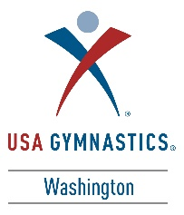
2017 Washington Men’s State Clinic

Hello Parents!

If your son competed level 4, level 5, or level 6 this year, he is eligible to attend the 2017 WA State Clinic’s open training sessions. In these sessions, your son will get to work with the guest clinician, Sergei Pakanich from WOGA, and with the best coaches in the state. They will go through event rotations where they will learn drills to help them progress to the next level.

Athlete registration cost: $60.00
Dates: June 3rd-4th, 2017
Location: Metropolitan Gymnastics (6822 S 190th St, Kent, WA 98032)
Open training session dates and times: Level 4* Saturday June 3rd, 1:00pm-4:30pm
Level 5/6* Sunday June 4th, 1:30pm-5:00pm
* If your son competed level 4 in the 2017 season he should attend the Level 4 training session. These boys will be working skills and drills to help them get closer to advancement to level 5. The same is for those who competed level 5 and 6.

Registration Deadline: May 20th - then athletes from other states may register. Registrations will be accepted up until the date of the clinic if space allows. Please check the state website for availability (usagymwa.com).
How to register: You can now register your son online (usagymwa.com) on the clinic’s page.
Parent Q&A Meeting: There will be a parent presentation and Q&A with the State Chairman during the first hour of each training session.

Please contact the State Chairman Jeff Crockett with any questions about the state clinic!
usagymwa@gmail.com

